Annual Computation:

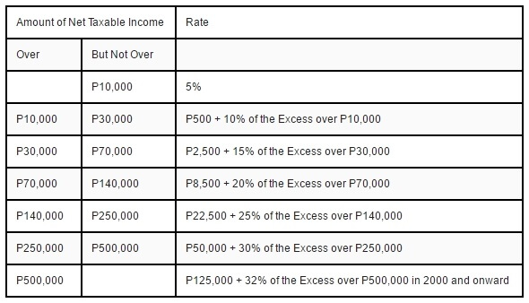

[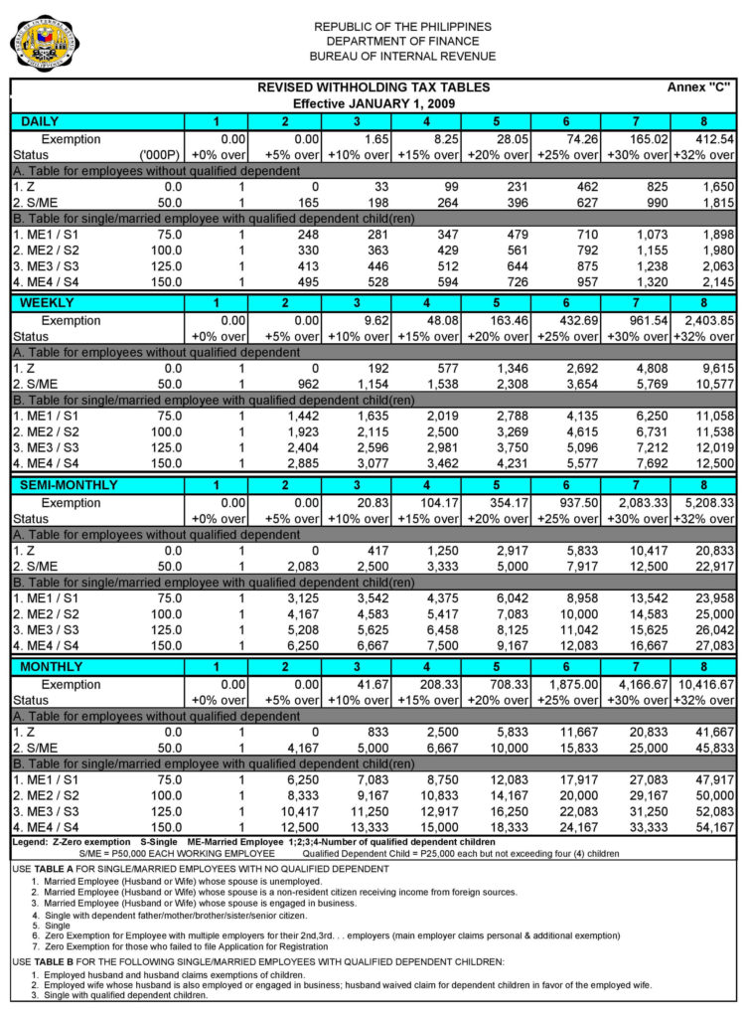](https://www.lilkuya.com/wp-content/uploads/2016/12/Withholding-Tax-Table.jpg)

